- Create database insurance;
2.
1.customers
CREATE TABLE customers (
customerID INT IDENTITY PRIMARY KEY,
FirstName VARCHAR(20) NOT NULL,
LastName VARCHAR(20),
DateOfBirth DATE,
phone VARCHAR(15),
email varchar(50) UNIQUE NOT NULL
)
2. Policies
CREATE TABLE Policies (
PolicyId INT PRIMARY KEY,
PolicyName VARCHAR(50),
PolicyType VARCHAR(50),
PremiumAmount DECIMAL(10,2),
DurationYear DATE
);
3.Agents
CREATE TABLE Agents (
AgentId INT PRIMARY KEY,
AgentName VARCHAR(20),
Phone VARCHAR(15),
City VARCHAR(20)
);

PolicyAssignments
CREATE TABLE PolicyAssignments (
AssignmentId INT PRIMARY KEY,
CustomerId INT,
PolicyId INT,
AgentId INT,
StartDate DATE,
EndDate DATE,

CONSTRAINT FK_Assign_Customer FOREIGN KEY (CustomerId) REFERENCES Customers(CustomerId),

CONSTRAINT FK_Assign_Policy FOREIGN KEY (PolicyId) REFERENCES Policies(PolicyId),

CONSTRAINT FK_Assign_Agent FOREIGN KEY (AgentId) REFERENCES Agents(AgentId)
);
5.Claims
CREATE TABLE Claims (
ClaimId INT PRIMARY KEY,
AssignmentId INT,
ClaimDate DATE,
ClaimAmount DECIMAL(10,2),
ClaimStatus VARCHAR(10),

CONSTRAINT FK_Claims_Assignment FOREIGN KEY (AssignmentId) REFERENCES PolicyAssignments(AssignmentId)
);

3.
INSERT INTO Customers (FirstName, LastName, DateOfBirth, Phone, Email) VALUES
('Racha', 'Kumar', '2003-05-14', '9876543210', 'racha@gmail.com'),
('Ananya', 'Sharma', '1998-11-22', '9123456780', 'ananya@gmail.com');

INSERT INTO Policies
VALUES
(101, 'Health Secure', 'Health', 12000.00, '2028-01-01'),
(102, 'Life Shield', 'Life', 18000.00, '2035-01-01');

INSERT INTO Agents
VALUES
(1, 'Suresh Rao', '9988776655', 'Hyderabad'),
(2, 'Meena Patel', '8877665544', 'Bangalore');

INSERT INTO PolicyAssignments
VALUES
(1001, 1, 101, 1, '2023-01-01', '2028-01-01'),
(1002, 2, 102, 2, '2024-06-01', '2035-06-01');

INSERT INTO Claims
VALUES
(5001, 1001, '2023-05-10', 25000.00, 'Approved'),
(5002, 1002, '2025-01-15', 40000.00, 'Pending');

INSERT INTO Customers (FirstName, LastName, DateOfBirth, Phone, Email)
VALUES
('Racha', 'Veeresham', '2001-09-18', '9012345678', 'racha.veeresham@gmail.com'),
('Manoj', 'Kumar', '2002-02-05', '9345678123', 'manoj.kumar@gmail.com'),
('Sravani', 'Reddy', '1999-07-12', '9567812345', 'sravani.reddy@gmail.com');

INSERT INTO Policies
VALUES
(103, 'Family Health Plus', 'Health', 25000.00, '2030-01-01'),
(104, 'Vehicle Protect', 'Motor', 8000.00, '2027-01-01'),
(105, 'Child Future Plan', 'Education', 15000.00, '2040-01-01');

INSERT INTO Agents
VALUES
(3, 'Ravi Teja', '9090909090', 'Warangal'),
(4, 'Priya', '9191919191', 'Kochi'),
(5, 'Arjun Singh', '9292929292', 'Delhi');

INSERT INTO PolicyAssignments
VALUES
(1003, 3, 103, 3, '2022-05-01', '2030-05-01'),
(1004, 4, 104, 4, '2023-03-15', '2027-03-15'),
(1005, 5, 105, 5, '2024-01-10', '2040-01-10');

INSERT INTO Claims
VALUES
(5003, 1003, '2023-11-20', 18000.00, 'Approved'),
(5004, 1004, '2024-02-05', 12000.00, 'Rejected'),
(5005, 1005, '2024-09-01', 30000.00, 'Pending');
4.Select Commands
1. Select * from Customers;
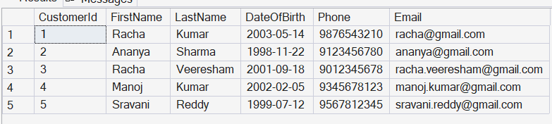
2. Select CustomerId,PolicyId,StartDate,EndDate from PolicyAssignments;
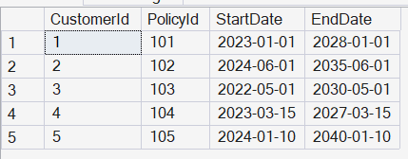
3. Select PolicyID,PolicyName from Policies where PolicyType = 'Health';
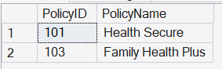

4. Select PolicyID,PolicyName from Policies where PremiumAmount > 10000.00 and DurationYear = 1;

5. SELECT DISTINCT City from Agents;
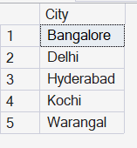
6. SELECT * from Policies where PolicyType = 'Health' or PolicyType = 'Life' or PolicyType = 'Motor';
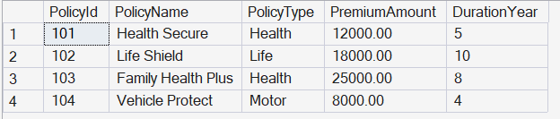
7. SELECT * from Policies where PolicyType in ('Health','Life','Motor');
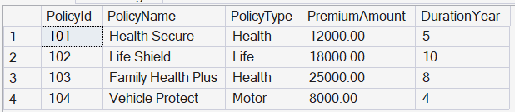

8. Select * from Customers where DateOfBirth>'2001-01-01' and DateOfBirth<'2020-12-31';
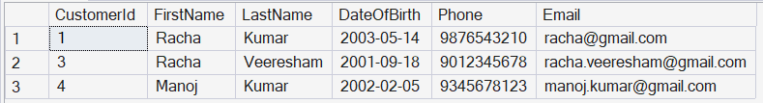
9. Select * from Customers where DateOfBirth between '2001-01-01' and '2020-12-31';
10. Select * from Claims where ClaimStatus = 'Rejected';
11. Select AgentName from Agents where City like '_a%';
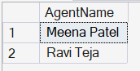
12. Select MAX(ClaimAmount) as max,MIN(ClaimAmount) as min from Claims;
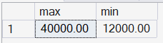
13. Select TOP 1 * from Claims ORDER BY ClaimDate DESC;
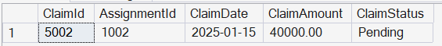
14. Select PremiumAmount * 1.10 from Policies;
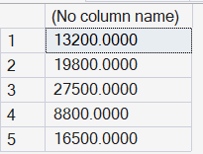

15. Delete from PolicyAssignments where EndDate < GETDATE();

16. Select COUNT(*) from Claims where ClaimStatus = 'Rejected';
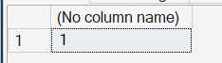
17. SELECT
PolicyId,
PolicyName,
PremiumAmount,
PremiumAmount*1.06 as PremiumAmountWithTax,
PremiumAmount/12 as MonthlyPremiumAmount
from Policies;
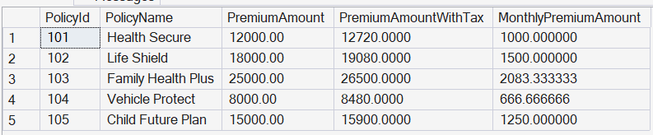
18. ALter TABLE Customers
ADD Addess VARCHAR(50),
City VARCHAR(50);

19. ALTER TABLE Agents
ADD DevOfId INT;

20. ALTER TABLE Agents
ADD CONSTRAINT FK_Agents_DevOf
FOREIGN KEY (DevOfId)
REFERENCES Agents(AgentId);

21. Select p.policyId,p.policyName
from Policies p
JOIN PolicyAssignments pa on pa.PolicyId = p.PolicyId where pa.CustomerId = 5;
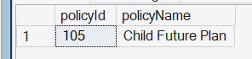

22. Select c.CustomerId,
c.FirstName,
c.LastName,
p.PolicyName
from Customers c
JOIN PolicyAssignments pa on pa.CustomerId = c.CustomerId
JOIN Policies p on p.PolicyId = pa.PolicyId;
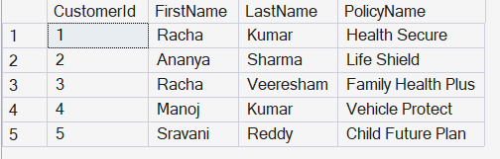
23.
Select
cl.ClaimId,
cl.AssignmentId,
cl.ClaimDate,
cl.ClaimAmount,
cl.ClaimStatus
from Claims as cl
JOIN PolicyAssignments pa on cl.AssignmentId = pa.AssignmentId
JOIN Customers c on pa.CustomerId = c.CustomerId;

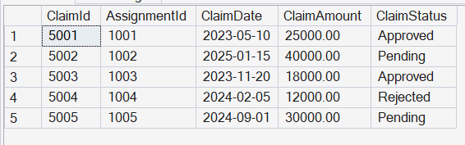
24.
Select
c.FirstName,
p.PolicyName,
a.AgentName,
pa.StartDate,
pa.EndDate
from Customers c
JOIN PolicyAssignments pa on pa.CustomerId = c.CustomerId
JOIN Policies p on pa.PolicyId = p.PolicyId
JOIN Agents a on pa.AgentId = a.AgentId;
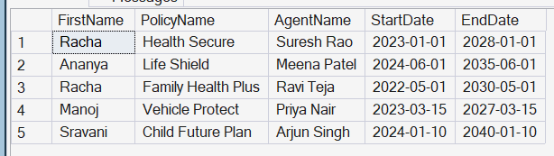
25.
Select
c.FirstName,
p.PolicyName,
cl.ClaimAmount,
cl.ClaimStatus,
cl.ClaimDate
from Claims cl
JOIN PolicyAssignments pa on cl.AssignmentId = pa.AssignmentId
JOIN Policies p on pa.PolicyId = p.PolicyId
JOIN Customers c on pa.CustomerId = c.CustomerId;

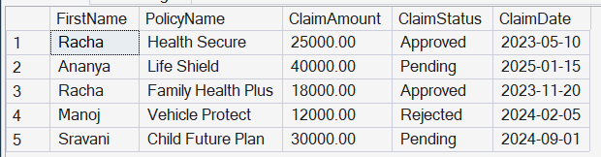

26.
Select
c.CustomerId,
c.FirstName,
c.LastName,
p.PolicyName,
pa.StartDate,
pa.EndDate
from Customers c
Left JOIN PolicyAssignments pa on c.CustomerId = pa.CustomerId
LEFT JOIN Policies p on pa.PolicyId= p.PolicyId
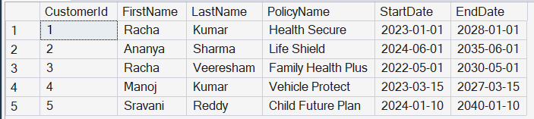

27.
SELECT DISTINCT
c.CustomerId,
c.FirstName,
c.LastName
FROM Customers c
LEFT JOIN PolicyAssignments pa
ON c.CustomerId = pa.CustomerId
LEFT JOIN Claims cl
ON pa.AssignmentId = cl.AssignmentId
WHERE cl.ClaimId IS NULL;
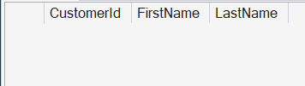

28.
SELECT
c.CustomerId,
c.FirstName,
c.LastName,
SUM(cl.ClaimAmount)
FROM Customers c
JOIN PolicyAssignments pa ON c.CustomerId = pa.CustomerId
JOIN Claims cl ON pa.AssignmentId = cl.AssignmentId
GROUP BY
c.CustomerId,
c.FirstName,
c.LastName;

29. SELECT
c.FirstName,
c.LastName,
SUM(cl.ClaimAmount) AS TotalClaimAmount
FROM Customers c
JOIN PolicyAssignments pa
ON c.CustomerId = pa.CustomerId
JOIN Claims cl ON pa.AssignmentId = cl.AssignmentId
GROUP BY
c.FirstName,
c.LastName
HAVING SUM(cl.ClaimAmount) > 50000;


SELECT
a.AgentId,
a.AgentName,
COUNT(pa.PolicyId)
FROM Agents a
LEFT JOIN PolicyAssignments pa
ON a.AgentId = pa.AgentId
GROUP BY
a.AgentId,
a.AgentName;
